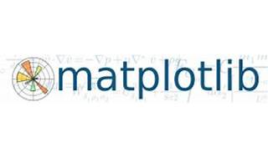

Matplotlib

Explore

**Matplotlib** is a comprehensive library for creating static, animated, and interactive visualizations in **Python**. [It simplifies common tasks and enables complex visualizations, allowing you to create publication-quality plots, interactive figures, and customize visual styles and layouts1](https://matplotlib.org/).

Here are **five free reference links** where you can learn more about Matplotlib:

1. [**Matplotlib Official Documentation**](https://matplotlib.org/): The official documentation provides detailed information, examples, and guides on using Matplotlib for various visualization tasks.
2. [**Matplotlib on PyPI**](https://pypi.org/project/matplotlib/): This page offers an overview of Matplotlib and its capabilities, along with installation instructions.
3. [**Getting Started with Matplotlib**](https://matplotlib.org/stable/users/installing/index.html): Learn how to install Matplotlib and get started with basic usage.
4. [**Matplotlib Users Guide**](https://matplotlib.org/): Explore the user guide for comprehensive explanations and practical examples.
5. **StackOverflow Matplotlib Tag**: Join the StackOverflow community to ask questions, share your work, and discuss contributing to Matplotlib.

Happy plotting! 📊🐍